Case 5-Asia-China-Liangzhu-Feather Post-Trapezoidal-Jade-Early Liangzhu Period-3400-2800 BCE

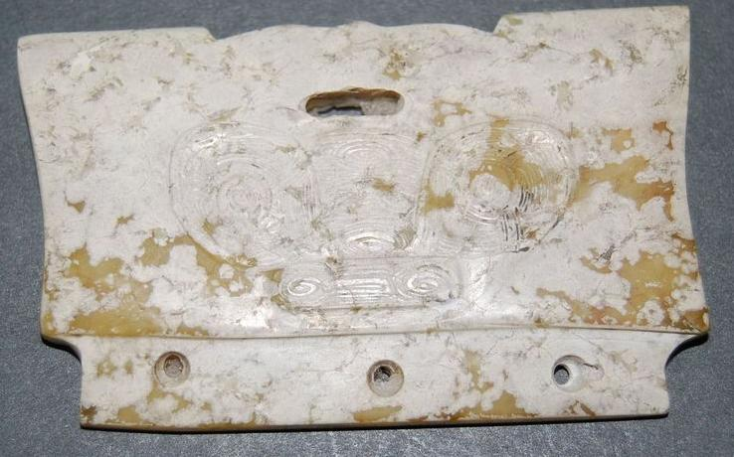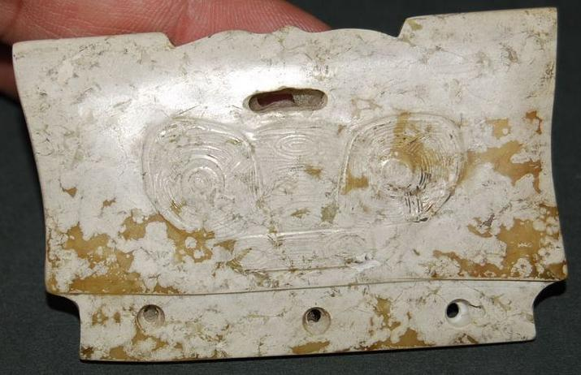

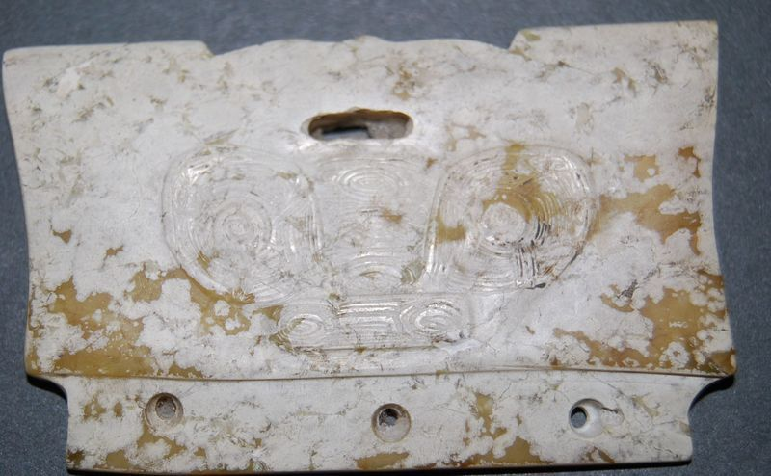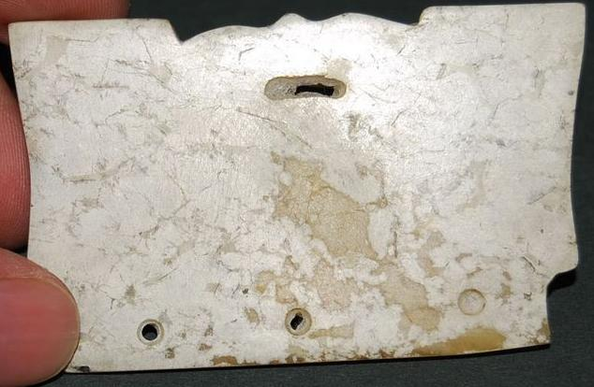
A000-Asia- China-Liangzhu-Feather Post-Trapezoidal-Jade-Early Lianzhu Period-3400-2800 BCE
Figs. 1-4. China-Liangzhu-Feather Post-Trapezoidal-Jade-Early Lianzhu Period-3400-2800 BCE
Case no.: 5
Accession Number:
Formal Label China-Liangzhu-Feather Post-Trapezoidal-Jade-Early Lianzhu Period-3400-2800 BCE
Display Description: Feather posts may have been used in headdresses when fitted with decorative feathers and attached to a comb-like device. The anthropomorphic image on the verso of this jade plaque is similar to images carved on cong and is related to the iconography of Shaman images found on other Liangzhu jade objects. In addition, on the upper right-hand and left-hand corners of this plaque are two bird images which are iconographic symbols indicating the movement of Earth around the Pole Star. As such they are also symbols of observations of Liangzhu shaman-astronomers who made observations regarding this phenomenon. These plaques have been found carefully laid on the heads of the deceased. The brown staining is due to the penetration of hematic fluids of the deceased.
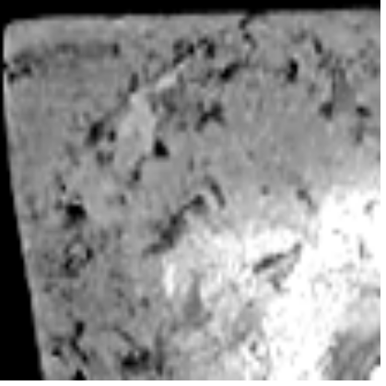
Fig. 2 a. bird images which are iconographic symbols indicating the movement of Earth around the Pole Star.

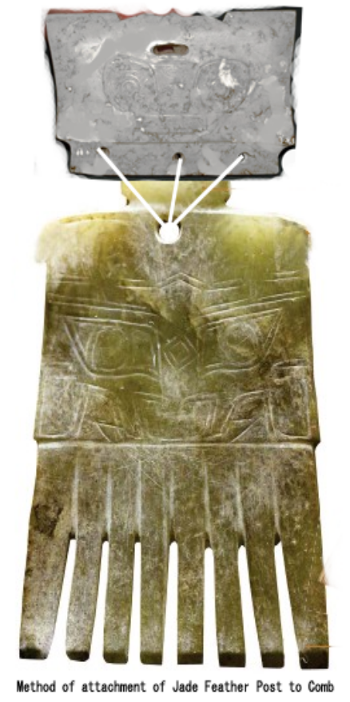
Fig. 5. Method of attachment of Jade Feather Post to comb. Feathers, if attached to the central ovate hole in the top of the Jade Feather Post, would have reified the bird images at the top corners of the Jade Feather Post symbolizing the Heavenly movement of Earth around the Pole Star.

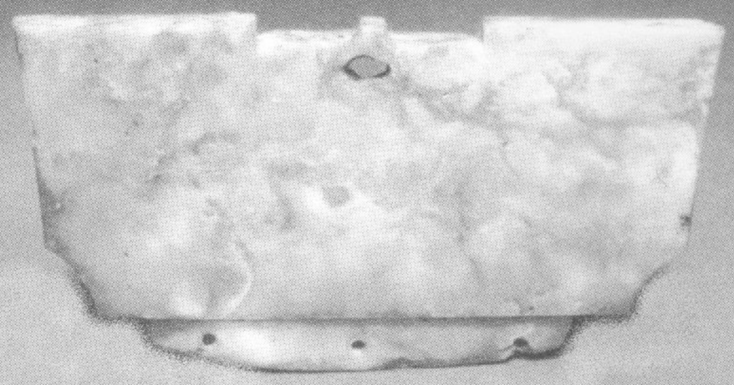
Fig. 6. Trapezoidal Jade Feather Post Liangzhu culture, ca. 3200-2300 BCE, aniconic, probably of the Songze culture in the Shanghai region, Shanghai Museum. Dimensions not given. After Childs-Johnson 1988, no. 68, p. 21b.

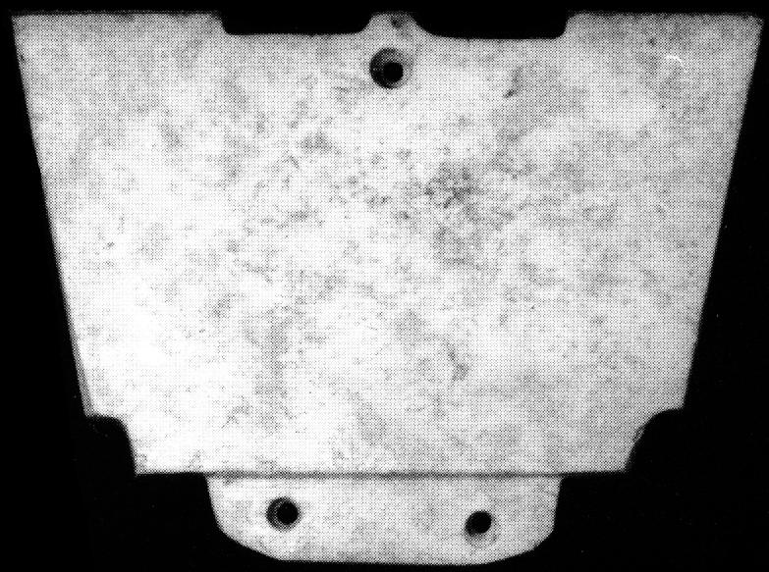
Fig. 7. Trapezoidal comb ornament, southeast China, late Neolithic Period, Liangzhu culture, ca. 3200-2300 BCE, Richard J Salisbury Collection, New Jersey. 4.7 cm. high, 6.5 cm. wide, 0.5 cm. thick. After Childs-Johnson 1988, no. 68a, p. 21. Other trapezoidal comb ornaments were documented through archaeological excavations at Yaoshan and Fanshan.

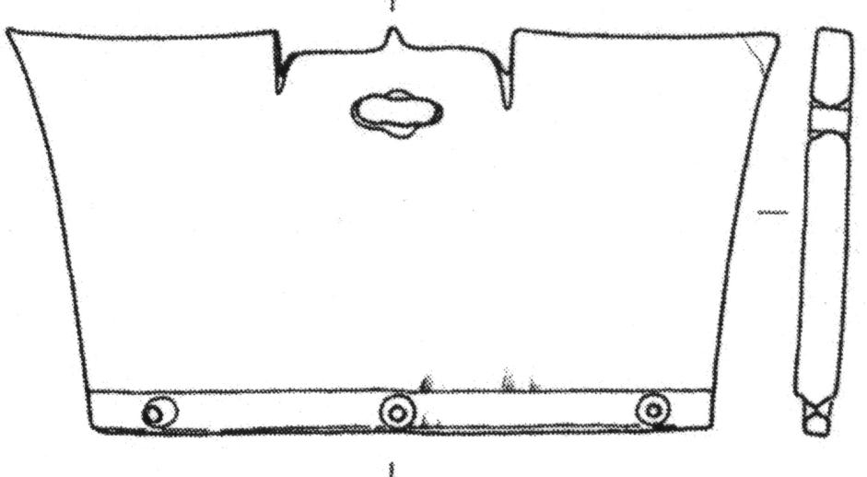
Fig. 8. Trapezoidal Jade Feather Post Liangzhu culture, ca. 3200-2300 BCE, aniconic, from Yaoshan, E 3-3, M12: 2850, after Childs-Johnson 2009, Fig. 15, p. 344.

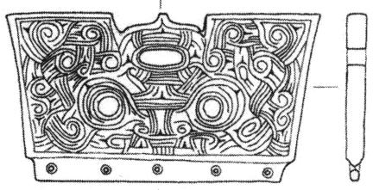
Fig. 9. Trapezoidal Jade Feather Post Liangzhu culture, ca. 3200-2300 BCE, with Shamanic mask face and complicated curvilinear elements that indicate complicated observations of the Heavens by a Shaman-Astronomer, from Yaoshan, E 3-4, M11: 86, after Childs-Johnson 2009, Fig. 15, p. 344.
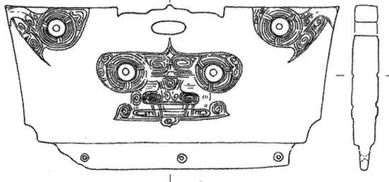
Fig. 10. Trapezoidal Jade Feather Post Liangzhu culture, ca. 3200-2800 BCE, with Shamanic mask and raptorial bird heads as Heavenly carriers of Earth around the Pole Star from Fanshan, E 3-5, M22:11, after Childs-Johnson 2009, Fig. 15, p. 344.
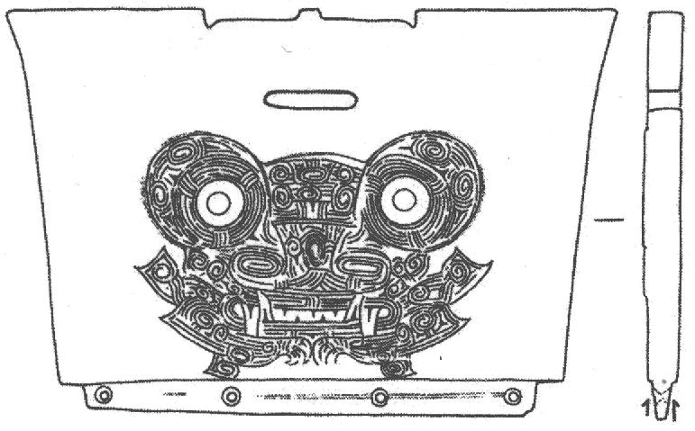
Fig. 11. Trapezoidal Jade Feather Post Liangzhu culture, ca. 3200-2300 BCE, with Shamanic transformational Tiger Mask from Fanshan, E 3-2, M17:8, after Childs-Johnson 2009, Fig. 15, p. 344.
LC Classification: NK5750.2.A1
Date or Time Horizon: Liangzhu culture, lower Yangzi River Valley, early Liangzhu Period, ca. 3200-2800 BCE Geographical Area: Liangzhu culture, lower Yangzi River Valley
Maps:
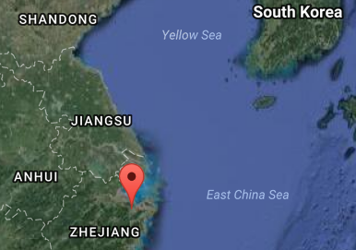
Fig. 12. Locastion of Liangzhu site proper.Source: Google Earth

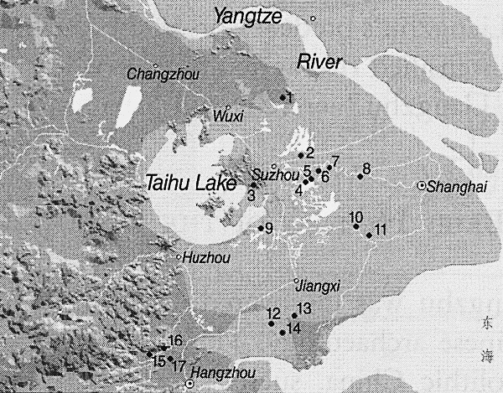
Fig. 13. Detail of Liangzhu site complex surrounding Taihu. After Zhou Ying 2007.

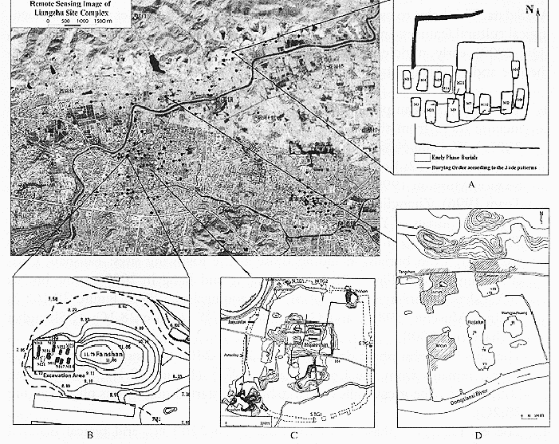
Fig. 14. Detail of Liangzhu site complex (A, C, D) and Liangzhu site proper (B). After Zhou Ying 2007.

GPS coordinates of Fig. 7 B:
Northeast corner: N 30°24'48", E 120°00'17"
Northwest corner: N 30°24'41", E 119°58'58"
Southeast corner: N 30°23'20", E 120 00'19"
Southwest corner: N 30°22'55", E 119°58'28"
GPS Coordinate on Map as approximate average: N 30°24', E 120 00'
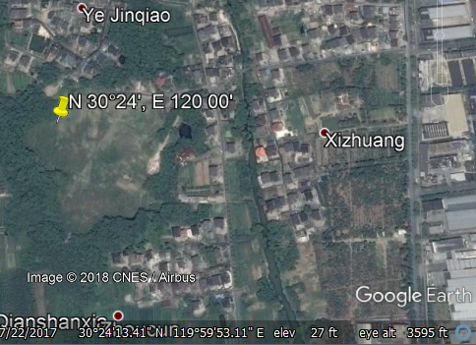
Fig. 8 Liangzhu site proper (Fig. 7B). After Google Earth.
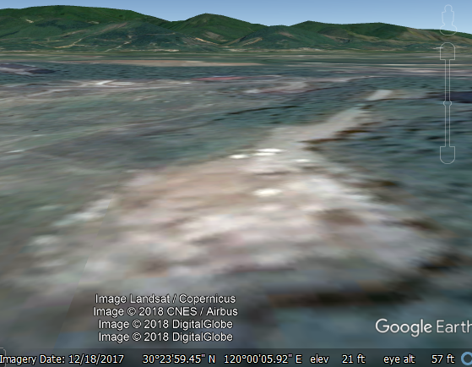
Fig. 15. Liangzhu site proper (Fig. 7B) and mountains in background. After Google earth, ground view.
Dimensions: H 2.375, W 3.25 in., D 3.25 in., hole Dia 2.5 in.,
Weight: 425 gm.
Condition: original
Provenance:
Discussion:
Liangzhu (3400–2250 BCE) in Yuhang County, Zhejiang, became a highly stratified society in the latter Liangzhu Period ca 2800-2250 BCE when élites began to control a sphere of influence that extended north to Shanxi and south to Guangdong. Jade and other expensive wares (such as silk, lacquerware, and ivory) characterized the social symbolism of Liangzhu élites which they used in ritual performances and dances as well as in grave goods. In this period the previous rôle of the shaman was curtailed in its psychological component and elevated in its rational component as astronomer.
DNA from Liangzhu culture sites around Taihu Lake the Yangtze River exhibit high frequencies of Haplogroup O1 which was absent in other archaeological sites that were sampled inland of the Liangzhu complex. Haplogroup O1 is common to modern Austronesians and Taiwanese Aborigines/Taiwanese Austronesians (TAN) (O1) probably came from those Liangzhu Austronesians (LAN) who had been displaced from the mouth of the Yangtze River delta by an economic crash of the LAN ca 4500 BCE induced by a meteor that struck at the present location of Taihu Lake, a meteoric crater. Recent studies show that special micro-fractures in quartzite were formed during the unloading process after the compression at the peak of an impact event (Wang, Wan, Xu 2002). LAN culture sites that existed around Taihu Lake and the mouth of the Yangtze River succumbed by ca 4200 BP LAN to a series extreme floods from diversions of the Yangtze River that interrupted the cultural layers with intrusions of mud and sand. It took 800 years, from 4200 BCE until 3400 BCE, for the Liangzhu culture on the mainland to recover. At the end of this time-horizon, Taiwanese migrants began to sail east to the Buka Strait in the Solomon Islands which became a staging area for the populating of Polynesia ca 2500 BCE.

References:
Biot, Jean Baptiste. 1851. Le Tcheou-li: ou, Rites des Tcheou. Paris: Imprimerie nationale, 1851. 3v.

Chang, K.C., Xu, P. and Lu, L. 2005. The formation of Chinese civilization: an archaeological perspective. New Haven: Yale University Press.

Childs-Johnson, Elizabeth. 1988. Ritual and Power: Jades of Ancient China. New York: China House Gallery, China Institute in America.

Childs-Johnson, Elizabeth. 2009. “The Art of working Jade and the rise of civilization in China.” In Elizabeth Childs-Johnson, Early Chinese jades in American Museums. Beijing: The Science Press, China Science and Technology Publishing and Media Co., Ltd., 2009, pp. 291-393.

Gu Fang. 2005. Complete collection of unearthed jades in China. 15 v. Beijing: China Science and Technology Publishing and Media Co., Ltd.

Hayashi, Minao. INCLUDEPICTURE "http://lms01.harvard.edu:80/exlibris/aleph/u20_1/alephe/www_f_eng/icon/f-separator.gif" \* MERGEFORMATINET INCLUDEPICTURE "http://lms01.harvard.edu:80/exlibris/aleph/u20_1/alephe/www_f_eng/icon/f-separator.gif" \* MERGEFORMATINET INCLUDEPICTURE "http://lms01.harvard.edu:80/exlibris/aleph/u20_1/alephe/www_f_eng/icon/f-separator.gif" \* MERGEFORMATINET 林巳奈夫. 1991. Chūgoku kogyoku no kenkyū. INCLUDEPICTURE "http://lms01.harvard.edu:80/exlibris/aleph/u20_1/alephe/www_f_eng/icon/f-separator.gif" \* MERGEFORMATINET INCLUDEPICTURE "http://lms01.harvard.edu:80/exlibris/aleph/u20_1/alephe/www_f_eng/icon/f-separator.gif" \* MERGEFORMATINET INCLUDEPICTURE "http://lms01.harvard.edu:80/exlibris/aleph/u20_1/alephe/www_f_eng/icon/f-separator.gif" \* MERGEFORMATINET 中國古玉の研究. Tōkyō : Yoshikawa Kōbunkan; 東京 : 吉川弘文館, 1991.

Hayashi, Mineo. 1990. “On the Chinese Neolithic jade Tsung/Cong,” Artibus Asiae, 50(1/2):5-22.

Hayashi, Mineo. 1973. Toyo Gakuho [Journal of the Research Dept. of the Toyo Bunko] 45:1-57.

Laufer, Berthold. 1912. Jade a study in Chinese archaeology and religion. Field Museum of Natural History, Publication 154, Anthroplogical series, vol. X. Chicago.

Li, Hui; Huang, Ying; Mustavich, Laura F.; Zhang, Fan; Tan, Jing-Ze; Wang, ling-E; Qian, Ji; Gao, Meng-He; Jin, Li. 2007. "Y chromosomes of prehistoric people along the Yangtze River," Human Genetics 122: 383–388.
Wang Erkang, Yuqiu Wan, Shijin Xu. 2002. “Discovery and implication of shock metamorphic unloading microfractures in Devonian bedrock of Taihu Lake,” Science in China Series D: Earth Sciences, 45 (5): 459–467.

Lu Wenbao. 1998. Cong-shaped bead. In Liangzhu Culture Museum, ed., The dawn of Chinese civilization: Jades of the Liangzhu culture. Hong Kong: Liangzhu Culture Museum and The Art Museum, The Chinese University of Hong Kong.

Wu, Li. 2014. "Holocene environmental change and its impacts on human settlement in the Shanghai Area, East China," Catena 114: 78–89

Zhang, Chia; Hsiao-Chun, Hung. 2008. "The Neolithic of Southern China–Origin, Development, and Dispersal,"Asian Perspectives. 47:2, 309–310.

Zhou Ying. 2007. 东方文明的曙光: 良渚遗址与良渚文化 = Dong fang wen ming de shu guang : Liang zhu yi zhi yu liang zhu wen hua = The Dawn of the Oriental Civilization: Liangzhu site and Liangzhu culture. Beijing: China Intercontinental Press.

